REGISTRATION FORM

Mr/Mrs/Miss/Ms

(First Name/s) (Surname)

Preferred Name Maiden/Other Surname

Address:

Town Post Code Country

Home Phone Occupation

Mobile Phone Email

Are You Registered with Ngāi Tahu Yes No If yes, what is your registration number

The runanga office sends e-panui to email as listed above, you may opt out of this at any time. Alternatively, this can be posted to you. Do You Wish To Receive Correspondence By Email or Post? Email Post

PLEASE COMPLETE WHAKAPAPA CHART ON THE SECOND PAGE OF THIS FORM

PLEASE LIST THE 1848 KAUMĀTUA THAT YOU CLAIM YOUR TE RUNANGA o WAIHAO DESCENT FROM

Attention is drawn to Sections 7, 8, & 13 of the “Te Rūnanga o Ngai Tahu Act 1996”,
together with the 1848 list of Ngai Tahu Kaumātua (generally referred to as the Blue Book)

1848 Kaumatua | Kaumātua Number | File Number
1

2

3

4

5

6

7

DECLARATION:
I do solemnly and sincerely declare:

That I was born at__________________________on the_____________day of____________of the year__________________
(A copy of the applicant’s full birth certificate can be attached to this application (Optional). Do not send originals, as they will not be returned)
- That I am Ngai Tahu in terms of the “Te Runanga o Ngai Tahu Act 1996”
- That I am a blood descendant of the 1848 Kaumatua of Te Runanga o Waihao iwi as listed above
- That the Whakapapa on the reverse side of this form indicating my blood descent from the said “1848 Kaumatua” is true and correct
I acknowledge that the information contained in this form provided by me to Te Runanga o Waihao Inc is subject to the Privacy Act 1993; and that by signing this form, I agree that Te Runanga o Waihao Inc may use this information to maintain its Papatipu Runanga voting rolls, contact databases and any other purpose which Te Runanga o Waihao considers reasonable, whilst performing its statutory role.

SIGNATURE Date

(Parents or Guardians may sign this application on behalf of minors)

Check List
Entered FULL NAME and CONTACT DETAILS. Office use Only
SIGNED and DATED the application. DB No __________
COMPLETED WHAKAPAPA details on the back of this. Date Received ___/___/___
ENCLOSED a copy of full birth certificate. Presented to Meeting ___/___/___
Date Entered ___/___/___
Post to: Te Rūnanga o Waihao, 26 Māori Road, RD 10, WAIMATE 7980
This application will not be accepted unless fully completed.

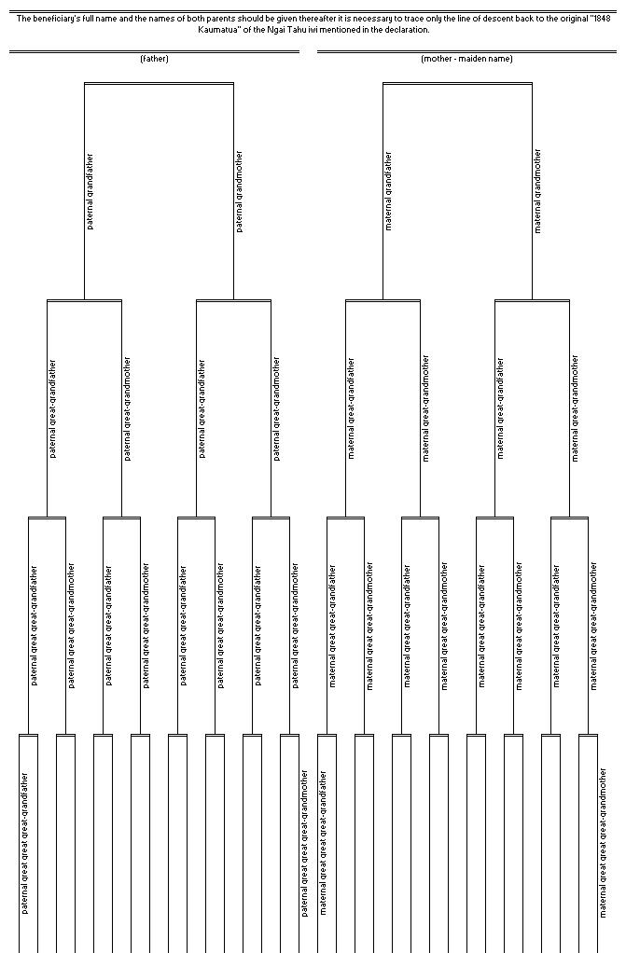Te Rūnanga o Waihao Whakapapa

